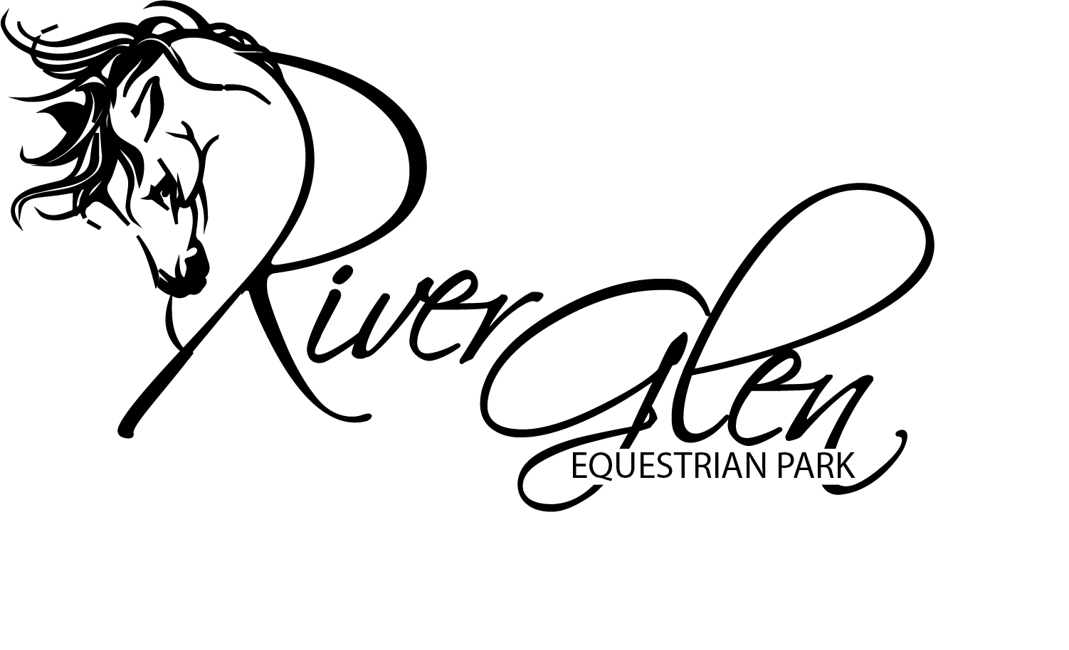
Action Plan for River Glen Equestrian Park August Horse Trials 2020
Protocols and safeguards implemented for protection against COVID-19
This plan outlines the steps and precautions River Glen Equestrian Park will implement to ensure, as much as possible, the safety and welfare of our participants, officials, volunteers and staff during the current COVID-19 situation.
While there is no way to eliminate all risks related to COVID-19, the following guidelines are aimed to decrease the risk of COVID-19 infection.
We ask that everyone exercise caution, take precautionary measures, be accountable, and utilize good judgement at all times while interacting with one another while on grounds.
Failure to follow guidelines may result in expulsion from the show grounds. Management reserve the right to change the guidelines when/if it becomes necessary.
Taking into consideration CDC guidelines, State and local recommendations and the USEF Action Plan for Licensed Competitions, the following are listed as either Required or Recommended.
If you plan to come to the competition grounds, you must be able to assure management that neither you nor any one in your household:
- Has tested positive, or has been presumed positive for COVID-19, or has been advised by a healthcare professional to self-quarantine during the last 14 days.
- Has been in close physical contact with someone who has tested positive for COVID-19 in the past 14 days.
- Has, within the past 24 hours, exhibited any of the following symptoms attributed to COVID-19, including but not limited to: fever of 100.4 or greater, cough and shortness of breath.

Attention
>All entries will be online and must be complete prior to arrival.
>Riders Packets/Dressage Test will be available for collection from tables under a tent, set beside the red barn.
> Cross Country Maps will be posted on the score board and at the start boxes for competitors to take a photo. There will be no printed copies available.
>All scoring will be published electronically on Startbox.com at the end of each division.
>Details for FEI Riders meeting and Horse Inspection procedures will be documented separately and sent out to FEI Riders to ensure guidelines are addressed during these phases.
*Until further notice NO spectators, NO extended family or friends. If you are NOT directly involved with a horse or pony competing you are NOT allowed on competition ground.

REQUIRED For PARTICIPANTS
- Provide emergency contact information and execute an updated Waiver and Release of Liability Assumption of Risk and Indemnity Agreement required by USEF.
- Participants are required to self-monitor their temperature once daily prior to entering the competition grounds. Anyone with a temperature of 100.4° F (38° C) or higher may not enter the facility.
- Anyone who exhibits COVID-19 symptoms, has tested positive for COVID-19 within last two weeks, or has been in contact with someone who has tested positive for COVID-19 within the last two weeks cannot enter the competition grounds.
- Participants are required to wear a facemask or face covering when in any setting where there is a possibility of being within six feet of other individuals and when not mounted on a horse. **A participant may choose to wear a facemask or face covering when mounted on a horse
- Comply with social distancing requirements (6’ between individuals) at all times while on the competition grounds. Do Not gather in groups.
- Wash hands often with soap and water if available, or use hand sanitizer that contains at least 60% alcohol and adhere to other sanitization practices throughout the day.
- If anyone who was present on competition grounds test positive for COVID-19 within 14 days of the conclusion of the competition they must notify River Glen immediately.
- Dogs must be kept leashed at all time while on grounds.

RECOMMENDATIONS for PARTICIPANTS
Although not required participants are strongly encourage to follow the Recommendations for Participants at all times while present on the competition grounds.
- Use of thermometers to monitor your temperature throughout the day.
- Limit those accompanying you to the competition to essential support members.
- Provide adequate food and beverage supplies for your barn and your support members for the duration of the competition to avoid unnecessary community exposure.
- Use hand sanitizer, gloves, masks, and other PPE that you deem necessary and use these items on a regular basis.
- Do not mix equipment (tack, grooming supplies, lead shanks, etc.) and sanitize between each use.
- Regularly sanitize bikes/motorbikes/golf carts/car & truck door handles, stable doors, bucket handles, light switches, etc., and equipment including tack, grooming, feeding, stall cleaning materials, etc.
If you or someone you know presents with COVID-19 symptoms while on grounds notify River Glen personnel immediately, monitor your symptoms, and seek medical attention either from the on-site Paramedic/EMT, the local hospital or your personal health care provider. The ambulance can be used as a quarantine area if you are unable to leave grounds immediately. The nearest hospital and COVID-19 testing center will be posted at the office and in prominent area of the park.
We are happy to provide this opportunity to get back to what we all love and we’re happy you chose to spend your weekend with us! In today’s environment the situation requires that each and every one of us take personal responsibility for the health, safety, and welfare of ourselves, our family members, and our colleagues and peers in the competition environment.

Thank you,
River Glen Organizer Committee

Participants are required to comply with these and any additional Competition Organizer requirements at all times while present on competition grounds. Failure to do so may result in expulsion from the grounds. These requirements are in effect immediately and until further notice, however, they are subject to revisions as the COVID-19 virus environment changes.

